HD 13931

HD 13931 is a 1.02 M☉, G0V star1. Based on 66 RV HIRES measurements obtained between 1998 and 2019, the CL survey reported a LPGP signal with a period of days, a minimum mass of MJup and an eccentricity of .

In the present study, the CL survey's dataset was considered. DPASS and MCMC (1000 walkers and 300000 iterations) were used to fit the data. The properties found for HD 13931b reported in the CL survey were within the error bars associated with the values found in the present analysis. The fits are shown in Fig 1, and the corner plot in Fig 2, and the results summarized in Table 1.

Note that, recently, combining RV and Hipparcos/Gaia absolute astrometry data, a study performed in 20232 were able to estimate the orbital inclination, and thus the true mass, of HD 98649b. They found a period of days, an eccentricity lower than 0.04, an inclination of either ° or °, and a mass of MJup.

Conclusion: The properties found in the CL survey for HD 13931b are confirmed.

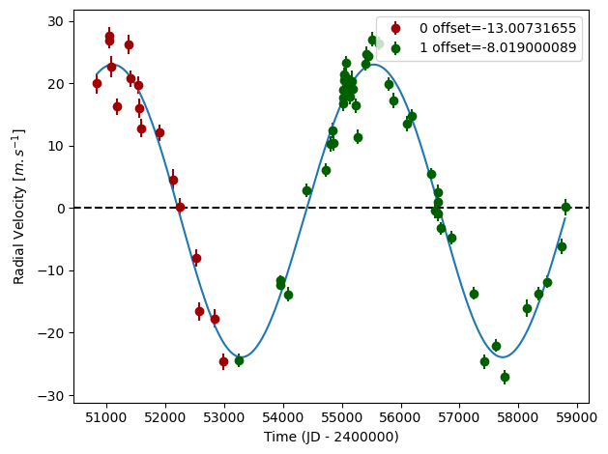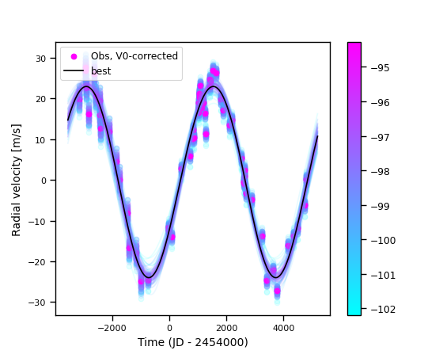

Figure 1: Left: fit of the HD 13931 RV with DPASS. Red - Hir94, green - Hir04. The blue curve shows the best fit. Right: fit of the HD 13931 RV using MCMC. The black curve shows the best fit. The colorbar corresponds to the log-likelihood of the fits.

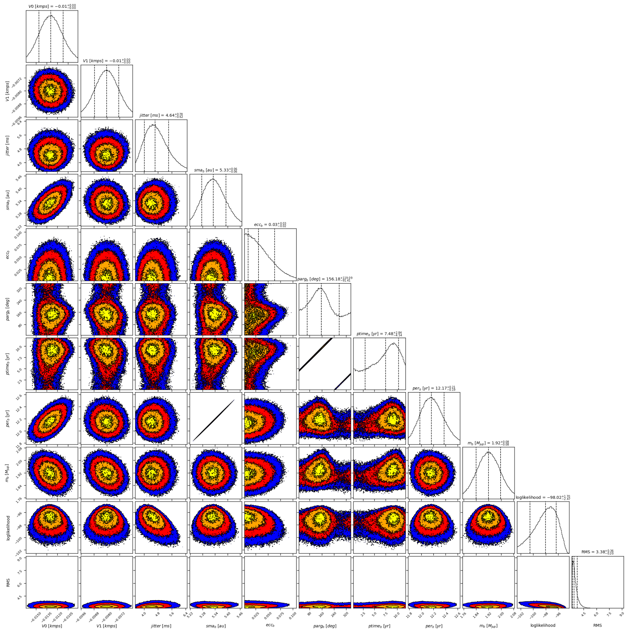

Figure 2: Corner plot of posteriors for the one-planet model MCMC fit of HD 13931 RV data.

| Parameter | Priors | | Posteriors | | CL survey |
| --- | --- | --- | --- | --- | --- |
|  | DPASS | MCMC | DPASS | MCMC |  |
| *a* (au) | [0,100] | [1,10] | 5.33 |  | 5.323 ± 0.091 |
| Msin(i) (MJup) | [0,200] | [0.1,10] | 1.92 | 1.92 ± 0.08 |  |
| Eccentricity | [0,0.95] | [0,0.95] | 0.02 | < 0.06 |  |
| Instrumentals offsets (km/s) | [-60,60] | [-1,1] | Hir94: -0.013  Hir04: -0.008 | Hir94: -0.013 ± 0.002  Hir04: -0.008 ± 0.001 |  |
| Stellar jitter (m/s) | [0,40] | [0,100] | 4 |  |  |
| Argument of periastron (°) | [0,360] | [0,360] | 151 | 65 – 275 |  |
| Phase | [0,1] | [0,1] | 0.92 | 0.24 – 0.85 |  |

Table 1: HD 13931. Summary of priors and posteriors obtained with DPASS and MCMC, compared to the properties reported by CL Survey.

References

1. Howard, A. et al. The California Planet Survey. I. Four New Giant Exoplanets. *Astrophys. J.* 721, 1467-1481 (2010).
2. Philipot, F. et al. Updated characterization of long-period single companion by combining radial velocity, relative astrometry, and absolute astrometry. *Astron. Astrophys*. 670, A65 (2023).